Kindly note that the information provided should not contain the following information: owner’s identity, trademarks, brand names, etc.
1. Title (Limit to 255 chars)
2. Technology Overview (Between 50 -250 words)
A brief summary or description of the invention - What is the problem solved by this technology? Who is going to buy this technology? How is this IP addressing a need/problem in the marketplace? Please do not mention your company or brand in any of the descriptions.
3. Technology Features and Specifications (min 50 words)
What does the technology comprise? E.g. Video camera, software algorithm
4. Potential Applications (min 50 words)
In which industry can this technology be employed? What are the products that can be marketed based on this technology
5. Customer Benefits (min 50 words)
How is this an improvement over the "State of the Art?" What is the Value Proposition?
6. Market Trends and Opportunities (optional)
What is the approximate market size for this technology? What makes this IP attractive to the market?
7. Graphic file
[paste images here]
Files must be less than 12MB, in the formats of png, gif, jpg or jpg. Images must be at least 638 x 425 pixels and you must have the rights to use the images.
8. File Attachments (optional)
[paste files here]
Files must be less than 10MB, in the formats of txt, pdf, doc, docx, ppt, pptx, xls, xlsx.

9. Technology Categories (See Annex 1)
10. Technology Readiness Level (See Annex 2 for reference table)
TRL 1 TRL 2 TRL 3 TRL 4 TRL 5 TRL 6 TRL 7 TRL 8 TRL 9
11. Date of Expiry
12. Keywords (optional)
13. Technology Status
Available Licensed but Available
14. Allow IPI to help market this TechOffer on other IPI Partner Portals
Yes No
15. Patent No (if any) and Additional Information on IP/Know-How (optional, not published)
Information on Additional IP/Know-How
Contact person’s details (For IPI’s use and reference only, not published):
Name :
Company :
Email :
Contact Number :
To create and submit your tech offer online, please visit www.ipi-singapore.org or enquire at techscout@ipi-singapore.org.

Annex 1 – Technology Categories
Chemicals
- Chemicals - Polymers/Plastic  - Chemicals - Others  - Chemicals - Inorganic  - Chemicals - Agrochemicals  - Chemicals - Catalysts | - Chemicals - Flavours and Fragrances  - Chemicals - Composites  - Chemicals - Coatings/Paints  - Chemicals - Analysis
Electronics
- Electronics - Actuators  - Electronics - Interconnects  - Electronics - Embedded Systems  - Electronics - Display  - Electronics - Lasers, Optics & Photonics | - Electronics - Memory and Storage  - Electronics - Radio Frequency  - Electronics - Power Management  - Electronics - Semiconductors  - Electronics - Printed Electronics  - Electronics - Sensors & Instrumentation
Energy
- Energy - Wind & Waves  - Energy - Waste-to-Energy  - Energy - Thermal System  - Energy - Solar  - Energy - Smart Metering / Management System  - Energy - Battery Management System | - Energy - Biofuels & Biomass  - Energy - Demand Response System  - Energy - Fuel Cells  - Energy - Battery & SuperCapacitor  - Energy - Performance Monitoring System & Sensor  - Energy - Power Conversion & Condition System
Environment, Clean Air/Water
- Environment, Clean Air/Water - Mechanical Systems  - Environment, Clean Air/Water - Filter Membrane/Absorption Material  - Environment, Clean Air/Water - Biological & Chemical Treatment  - Environment, Clean Air/Water - Monitoring System & Sensor | - Environment, Clean Air/Water - System Integration  - Environment, Clean Air/Water - Automation, Control, Communication  - Environment, Clean Air/Water - Sanitisation
Healthcare
- Healthcare - Telehealth, Medical Software & Imaging  - Healthcare - Medical Devices | - Healthcare – Diagnostics  - Healthcare - Pharmaceuticals & Therapeutics
Life Sciences
- Life Sciences - Biotech Research Reagents & Tools  - Life Sciences - Agriculture & Farming | - Life Sciences - Industrial Biotech Methods & Processes
Foods
- Foods - Commodities/Storage
- Foods - Packaging
Green Building
- Green Building - Simulation & BIM  - Green Building - Green Façade & Windows  - Green Building - Building Automation / Management  - Green Building - HVAC - Air Distribution | - Green Building - HVAC - Cooling System  - Green Building - Lightings  - Green Building - IAQ Monitoring & Control  - Green Building - HVAC - Cooling Tower Treatment
Infocomm
- Infocomm - Financial Technology  - Infocomm - Healthcare ICT  - Infocomm - Geoinformatics  - Infocomm - eCommerce & ePayment  - Infocomm - High Performance Computing  - Infocomm - Smart Cities  - Infocomm - Educational Technology  - Infocomm - Data Processing  - Infocomm - Computer Simulation & Modeling  - Infocomm - Cloud Computing  - Infocomm - Enterprise & Productivity  - Infocomm - Green ICT  - Infocomm - Internet of Things & Wearable Technology  - Infocomm - Interactive Digital Media & Multimedia  - Infocomm - Human-Computer Interaction  - Infocomm - Big Data, Data Analytics, Data Mining & Data Visualisation | - Infocomm - Augmented Reality, Virtual Reality & Computer-Simulated Environments  - Infocomm - Artificial Intelligence  - Infocomm - Ambient Intelligence & Context-Aware Computing  - Infocomm - Natural Language Processing & Semantic Technology  - Infocomm - Mobility  - Infocomm - Wireless Technology  - Infocomm - Networks & Communications  - Infocomm - Web Technology  - Infocomm - Video/Image Processing  - Infocomm - Speech/Audio Analysis  - Infocomm - Social Media, Collaboration & Crowdsourcing  - Infocomm - Security & Privacy  - Infocomm - Operating Systems  - Infocomm - Video/Image Analysis  - Infocomm - Speech/Audio Processing  - Infocomm - Robotics & Automation
Manufacturing
- Manufacturing - Surface Finishing/Modification  - Manufacturing - Subtractive Machining  - Manufacturing - Secondary Process  - Manufacturing - Additive Manufacturing  - Manufacturing - Assembly / Automation / Robotics | - Manufacturing - Moulding/Sintering/Casting/ Nanoimprinting  - Manufacturing - Joining  - Manufacturing - Forming  - Manufacturing - Chemical Processes
Materials
- Materials - Bio Materials  - Materials - Composites (Hybrid)  - Materials - Composites (Ceramic-Matrix)  - Materials - Composites  - Materials - Ceramics  - Materials - Composites (Metal-Matrix) | - Materials - Composites (Polymer-Matrix)  - Materials - Polymers  - Materials - Non-Ferrous Metals and Alloys  - Materials - Nano Materials  - Materials - Ferrous Metals and Alloys  - Materials - Semiconductors
Personal Care
- Personal Care - Cosmetics & Hair  - Personal Care - Wellness & Spa  - Personal Care - Fragrances | - Personal Care - Nutrition & Health Supplements
Wastes Management and Recycling
- Waste Management & Recycling - Thermochemical  - Waste Management & Recycling - Sorting  - Waste Management & Recycling - Pre-Treatment Processing  - Waste Management & Recycling - Mechanical System | - Waste Management & Recycling - Incineration  - Waste Management & Recycling - Energy Recovery  Waste Management & Recycling - Chemical & Biological Treatment

Return to Technology Categories entry
Annex 2 - TRL Reference Table
) 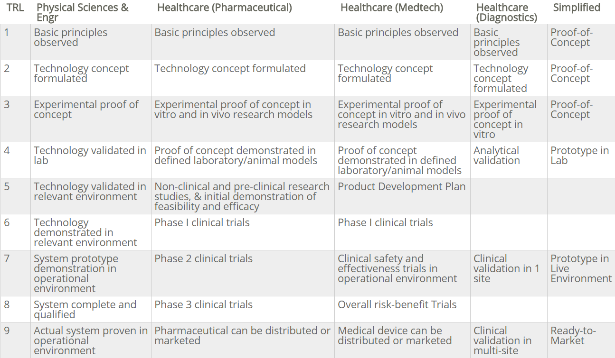

Return to TRL entry

